**Terminus - Part 1**

**The Linux Commands practice game**

**https://www.mprat.org/Terminus/**

When you get to the website you will see IMPORTANT instructions - remember them!

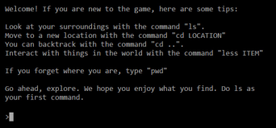

When you type in ls, you get a list of options. To play the game, you should skip the MIT location and only explore the Western Forest and the Northern Meadow. The MIT location is just info about the University. You can explore that later if you want.

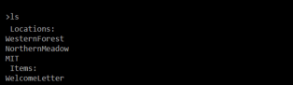

To get started, used the cd command to go into the Western Forest



**These questions will help you make sure you don’t miss anything. Write your answers in the space provided.**

1. Use the less command to read the signs outside the Spell Casting Academy. What are they giving away for free today?

2. And what is the command to get Home?

3. Go into the Spell Casting Academy and look around. You can speak to the Hurrying Student by using the less command. What advice does he give you?

4. Go into the Lessons room. What is the spell for moving objects?

5. Go into the Practice room (remember, you have to go back to level one first). Looking around, you see a box and some practice dummies. What happens if you try to go into the box?

6. What can you fit in the box? How many?

**You are done with the Western Forest, so go Home and then go into the Northern Meadow.**

7. You can even talk to animals with the less command! What kind of animal is this and are they friendly?

8. Before you go into the cave, talk to the Old Man and make sure to read his Old Manuscript. What command does he tell you about?

9. What is the entire file path from Home to the cave? Note: the pwd command will help but you need to trace back to each directory that you changed into. Provide answers in file path format - not sure what that means? Look at your notes!

10. How do you get from the Cave to the Dank Room?

11. How do you go forward through the Dank Room?

12. What is on the other end?

13. What new type of animal do you meet and is it friendly?

14. Where do you find the green light?

**STOP! We will move further through Terminus after learning some advanced Linux commands in a later section.**